# Education Level and Minimum Wage Rates

For any nation, high education levels and high minimum wage rates are desired. The U.S. government is constantly striving to achieve this. How can we as a nation monitor this? The goal of this report seeks to provide insight on the business question: **How does education level percent effect minimum wage rates by states?** We will look at historical numbers for these two metrics to identify if there is relationship between the two.

A dashboard was created in Tableau that illustrate out findings. The map shows states average minimum wage over time per state. States in red have a minimum wage below the average federal minimum wage and states in green are above. The minimum wage (in 2020 dollars) over time has increased slightly when accounting for inflation. Over time education levels have dramatically increased with about 36% increase in the population getting a high school education from 1970 -2019. Currently we can see that Louisiana, Texas and California have the highest percentage of people who do not have a high school education at about 16%. Discounting Porto Ricco, Florida, Arizona, and Oklahoma have the lowest minimum wage rate of the states. When comparing education level percentage and minimum age rate I have found that there is not correlation between the two. There are some states that have higher education level percentages than others but do not have higher minimum wage rates. Visualizing this is difficult because the education levels have time binned by decade serving a degenerate attribute.

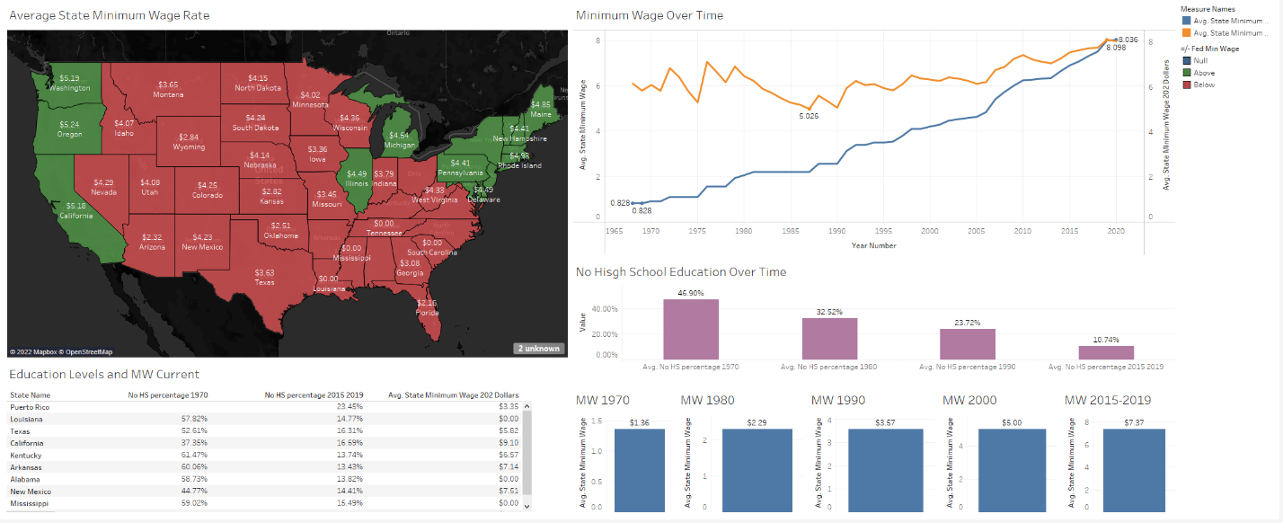 This dashboard can be useful to the U.S. government to establish how states have improved in producing educated people and identify which ones are the lowest performers. Furthermore, they can see if this has affected the minimum wage rate. Even though there is no noticeable relationship between the two, the government can still evaluate which states should need to find ways to raise their rate. an analytical view that can be used to view these metrics with future data.